Representative:

Manage collection point

Click “Manage Collection Point” link from menu and view current collection point.

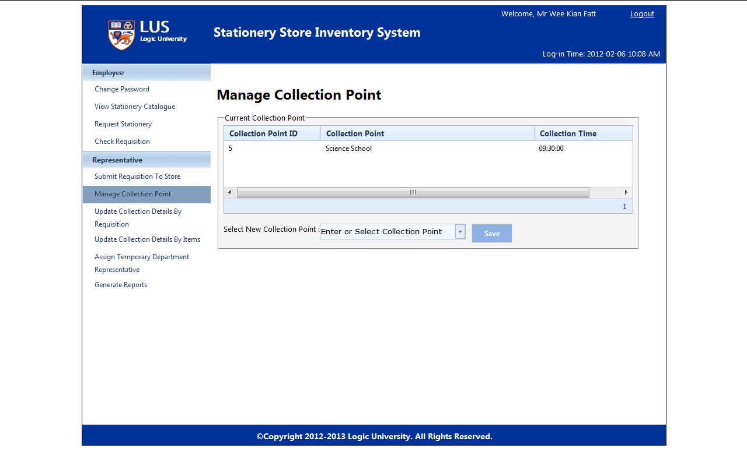

Select new collection point from list and click “Save”

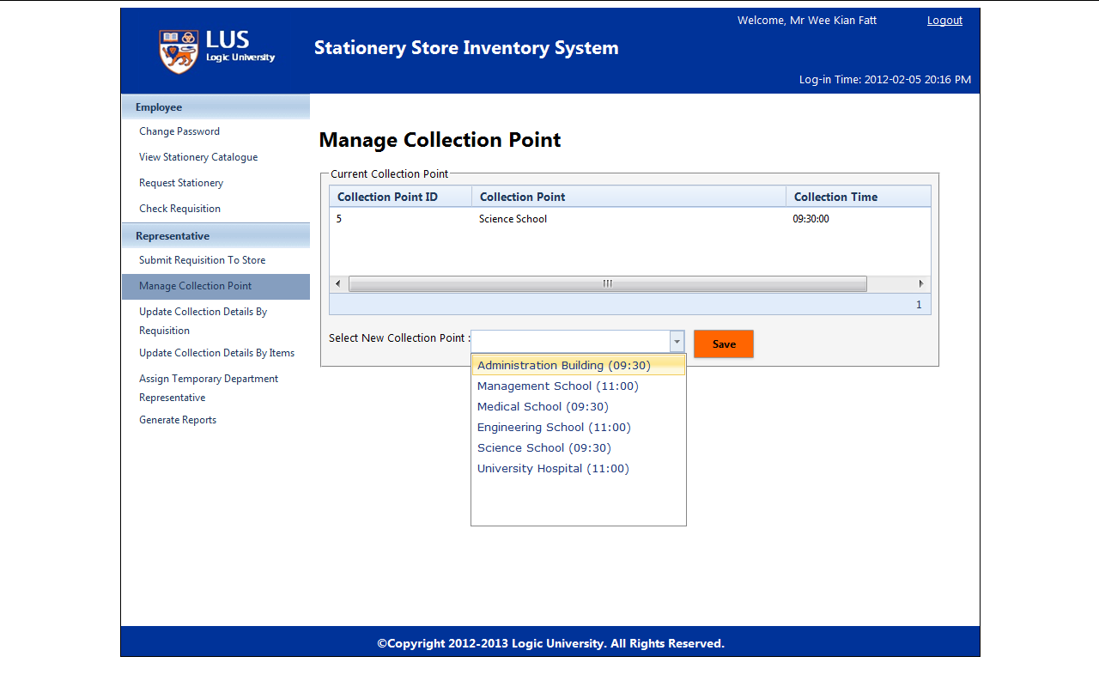

Selected new collection point will be saved in the “Current Collection Point”

